**Pengerjaan ARIMA**

* **R Studio**
* Melakukan import dataset



* Menghapus kolom ke-1



* Membuat data time series

* Melakukan plotting data

* Melakukan uji Augment Dickey-Fuller

* Melakukan uji Augmented Dickey-Fuller Test dengan difference



Setelah dilakukan difference sekali, data telah dianggap stasioner.

* Membuat canvas menjadi 2 baris dengan 1 kolom

* Melakukan Auto Correlation Function dan Partial Auto Correlation Function



* Mengidentifikasi model ARIMA yang cocok untuk diterapkan



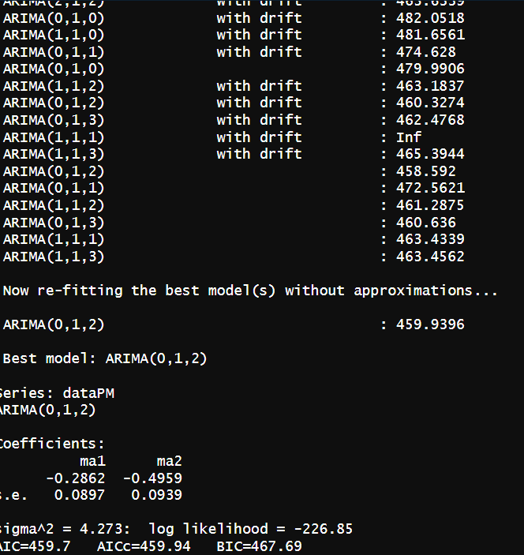

* Menerapkan model ARIMA (0,1,2) berdasarkan identifikasi

* Melakukan uji coefficient



* Mengukur metrik Akaike Information Criterion (AIC)





* Melakukan peramalan 15 hari ke depan (print ouput dan plotting)

* **Manual**